Abstract of Paper for Oral or Poster Presentation in IWAP2023
Title in Times New Roman (12pt Bold) Using First Capital Letter
F. Author¹, S. Author², T. Author^{1,2}.
(1) Institution, Department, City/Region, Country, first_author_email@address. (2) Institution, Department, City/Region, Country
The presenting author must be registered in IWAP2023. Abstracts should be written in English. The use of this template is compulsory for the paper to be considered for presentation. The abstract for both oral and poster presentations should not be longer than 1 page. Please, avoid using any non-standard abbreviations in the title. Abstracts can only be submitted electronically through the Easychair platform. The body of the abstract should be in one column with page margins of 1'' (top – bottom) and 1.25'' (left – right), and in Times New Roman 11pt (justified) font. Figures and tables may be included with caption underneath (in Times New Roman 11pt font) after the body of the abstract and be properly cited in the body at arithmetic order.

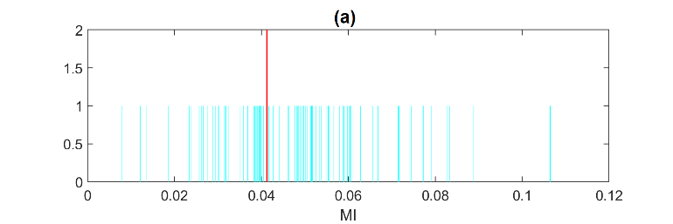
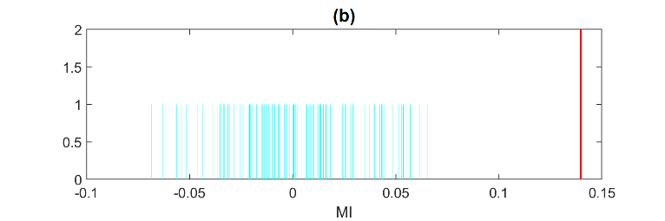
Figure 1: Randomization test of significance of mutual information (MI): no-rejection in (a) and rejection in (b).

The sections for acknowledgements and references should appear at the end of the abstract (Times New Roman 11pt font).
Acknowledgements (optional)
The acknowledgements should be written here. For assistance, you may contact IWAP2023 organizers by email to iwap2023@auth.gr.
References (optional)
[1] X. Author, Y. Author, Z. Author, Scientific Reports, 20 (2011) 537.
[2] X. Author, Y. Author, Z. Author, Proc. of Solar Chemistry and Photocatalysis: Environmental Applications, Las Palmas de Gran Canaria, Spain, 2006, 10.

